Overview
Every security control covered in Parts A through H is preventative. Part I assumes prevention has failed and addresses what happens in the first hours, days, and weeks after a breach is detected. For Eartigo, a breach is not a single category of event — it could mean a farmer's bank account details were exposed, a competitor gained access to GPS field boundaries and yield data, or an attacker compromised the admin panel and accessed Aadhaar verification records across thousands of farmers.
The team's task in this part is to help prepare a breach response checklist appropriate for an AgriTech platform processing farmer financial and farm intelligence data. This is not a generic incident response template — every step below is written with Eartigo's specific data categories and regulatory obligations (DPDP Act 2023, CERT-In Directions 2022, Aadhaar Act 2016, RBI guidelines) in mind.
The five steps are sequential but overlapping in practice: containment often begins before assessment is complete, and notification under CERT-In's 6-hour rule cannot wait for a full investigation.

Step 1: Identify — What Happened?
The first task during any suspected security event is to determine, as precisely as possible, what category of incident has occurred. This shapes everything that follows — different incident types trigger different containment actions, different notification obligations, and different recipients.
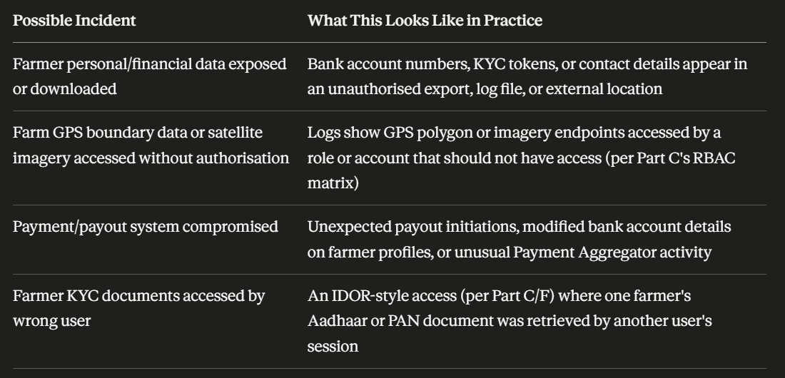
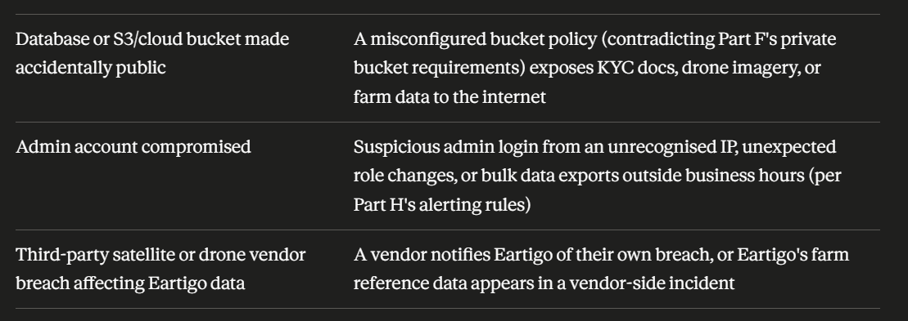

How the team identifies which scenario applies: This is where Part H's logging becomes operational. Review the AuditLog collection for the relevant time window, cross-reference against the alerting rules table, and check for anomalies in: login patterns, bulk export records, role change entries, and pre-signed URL generation events. The goal of Step 1 is a working hypothesis, not certainty — certainty comes in Step 3.

Step 2: Contain
Containment actions must begin the moment a credible incident is identified — even before the full scope is understood. The goal is to stop ongoing data exposure, not to investigate root cause yet.
- Disable affected API endpoints immediately
- Revoke all active tokens for affected users
- Change database credentials and API keys
- Block public access to affected cloud buckets
- Isolate affected server/microservice
- Stop further data exposure — pause payout processing if payment system affected

How Containment Maps to Earlier Parts
Disable affected API endpoints — If the breach involves a specific route (e.g., the farm boundary endpoint from Part C), the fastest containment is to disable that route at the load balancer or API gateway level, returning 503 to all callers, while investigation proceeds.
Revoke all active tokens for affected users — Use the revokeAllSessionsForUser function from Part G's token blocklist implementation. If the scope of affected users is unclear, consider a platform-wide token revocation by rotating the JWT signing secret — this invalidates every active session immediately, at the cost of forcing all users to re-authenticate.
Change database credentials and API keys — Rotate the MongoDB application user credentials (from Part D's database user separation), AWS access keys used for S3 (Part F), and any vendor API keys (satellite, drone, payment aggregator) that may have been exposed.
Block public access to affected cloud buckets — Re-apply the Block Public Access setting and the deny-public bucket policy from Part F immediately. Do not wait to understand how the bucket became public before locking it down again.
Isolate affected server/microservice — If a specific service (e.g., the AI crop analysis service or the drone imagery ingestion service) is suspected to be compromised, remove it from the load balancer pool and prevent it from making outbound connections, while preserving its state for forensic review.
Pause payout processing — If there is any indication the payment/payout system is compromised, halt all pending payout jobs immediately, even if this means delaying farmer disbursements by a day. A delayed payout is recoverable; an unauthorised one to an attacker-controlled account may not be.

Step 3: Assess
Once containment is underway, the team must determine the actual scope and severity of the incident. This assessment directly determines the notification obligations in Step 4 — under-assessing scope can lead to incomplete notifications, which carries its own regulatory risk.
- What categories of data were exposed? (personal, financial, farm intelligence)
- How many farmers/buyers are affected?
- Was Aadhaar, bank account, or payment data involved?
- Was farm GPS or satellite data accessed externally?
- Was data downloaded or exfiltrated?
- Was the breach internal or external?
- Was there malicious activity or is it accidental exposure?

Why Each Question Matters for Eartigo
What categories of data were exposed? — This question determines which parts of the Data Inventory (Part A) are implicated. A breach touching only product listing data (public, low sensitivity) is a fundamentally different event from one touching Category 1 (personal/financial) or Category 2 (farm intelligence — GPS, yield estimates) data.
How many farmers/buyers are affected? — Scale determines notification approach. A handful of affected accounts may warrant individual outreach; thousands of affected farmers may require a public notice in addition to direct communication, and changes the calculus on whether the Data Protection Board notification threshold is met.
Was Aadhaar, bank account, or payment data involved? — This question alone determines whether UIDAI and the Payment Aggregator partner need to be notified (Step 4). Given that Eartigo stores only tokenised/masked references for Aadhaar and bank data (per Parts A and D), the team should specifically check whether the exposure was limited to these tokens or whether it somehow reached the underlying values — the latter would indicate a deeper compromise of the KYC intermediary integration or encryption layer.
Was farm GPS or satellite data accessed externally? — As established in Part A, GPS boundary and yield data are commercially sensitive — equivalent to financial data in impact. External access to this data could mean a competitor, land speculator, or commodity trader gained insight into specific farmers' land and crop performance. This has different remediation implications (e.g., notifying affected farmers their land data may be known to third parties) than a purely internal data category breach.
Was data downloaded or exfiltrated? — Access logs (Part H) showing a record was viewed versus exported in bulk represent very different risk levels. Check the bulk_farmer_data_export and pre-signed URL generation audit events for volume and timing anomalies.
Was the breach internal or external? — An internal breach (e.g., an employee or contractor with legitimate access misusing it) triggers different containment (revoke that individual's access, review their full access history) and different notification considerations than an external attacker exploiting a vulnerability.
Was there malicious activity or is it accidental exposure? — A misconfigured S3 bucket left briefly public with no evidence of external access (accidental exposure, low/no actual harm) is treated differently from confirmed exfiltration by a malicious actor, though both may still trigger notification obligations depending on what was exposed and for how long.

Step 4: Notify

CERT-In 6-Hour Reporting

Under CERT-In Directions 2022, Eartigo must report cybersecurity incidents to CERT-In within 6 hours of detection. Do not delay notification waiting for full impact assessment. Report what is known and update as the investigation progresses.

The 6-hour clock starts at detection, not at the conclusion of Step 3. This means the team must be prepared to file an initial report to CERT-In with incomplete information — for example, "we have detected unauthorised access to an API endpoint serving farm boundary data; scope assessment is ongoing" — and follow up with updates as Steps 2 and 3 progress.

Notification Recipients and Timing

CERT-In — within 6 hours of detection (mandatory under IT Act)

Affected farmers and buyers — as soon as scope is confirmed

Payment aggregator partner — immediately if payment data is involved

UIDAI — if Aadhaar-linked data is involved (consult legal counsel)

Data Protection Board — when constituted under DPDP Act

Notes for Each Recipient

CERT-In — This is the only hard deadline in the list (6 hours). The report should be filed through CERT-In's incident reporting channels and should include: nature of the incident, systems affected, time of detection, and initial containment actions taken. The report can and should be updated as more information becomes available — CERT-In does not expect a final report within 6 hours, only the initial notification.

Affected farmers and buyers — Under the DPDP Act 2023, Data Principals whose personal data has been breached must be notified. For Eartigo, this notification should be in plain language, available in regional languages (consistent with the consent notice requirements from Part E), and should explain: what happened, what data was involved, what Eartigo is doing about it, and what the farmer or buyer should do (e.g., "we recommend you do not share OTPs received via SMS with anyone" if the breach involved phone numbers and there is a risk of social engineering follow-up attacks).

Payment aggregator partner — If there is any possibility that bank account tokens, payment references, or payout data were exposed, the Payment Aggregator must be notified immediately so they can monitor for fraudulent transactions on affected accounts and apply their own fraud controls. Per Part A's data localisation table, the PA relationship is governed by a DPA — that agreement likely specifies mutual breach notification timelines that may be shorter than CERT-In's 6 hours.

UIDAI — If the breach involves Aadhaar-linked data — even the masked tokens described in Part A and Part D — legal counsel should be consulted immediately regarding UIDAI notification obligations under the Aadhaar Act 2016. Given the criminal liability provisions around unauthorised Aadhaar data handling, this notification path should not be delayed pending internal debate about severity.

Data Protection Board — The DPDP Act establishes a Data Protection Board with authority to receive breach notifications from Data Fiduciaries (Eartigo's role, per Part B). As of this document's preparation, the Board's operational rules and notification mechanisms may still be in the process of being notified — the team should monitor for updates on this and ensure Eartigo's breach response plan is updated once the Board's processes are formalised.

Step 5: Improve

A breach response that ends at notification is incomplete. Step 5 ensures that the specific failure that allowed the breach does not recur, and that the broader security posture improves as a result of the incident.

Add missing validation and access checks

Improve API ownership verification

Update internal SOPs and playbooks

Train team on the specific failure mode

Record full incident report with timeline, root cause, and remediation

Conduct external security audit if breach was due to unknown vulnerability

How Step 5 Connects Back to the Rest of the Guide

Add missing validation and access checks — If the root cause was, for example, a missing ownFarmOnly check (Part C) on a new endpoint that was added after the original RBAC implementation, this step means auditing all recently-added endpoints against the Part C checklist, not just fixing the one identified vulnerability.

Improve API ownership verification — If the breach involved an IDOR-style failure (Part C, Part D), this is the point to review whether the four-layer check (authentication, role, tenant/farmer ownership, record-level ownership) was fully implemented, or whether a layer was skipped under time pressure during development.

Update internal SOPs and playbooks — This breach response plan itself (Part I) should be treated as a living document. Each real incident — or each tabletop exercise referenced in Part C's checklist — should result in concrete edits to this plan: updated contact lists, refined containment steps, or new "what happened" scenarios added to Step 1's list based on incidents not originally anticipated.

Train team on the specific failure mode — If the breach occurred because a developer was unaware of the magic-bytes validation requirement (Part F), or because a new team member didn't know the consent-logging requirement (Part E), this is a signal that onboarding and ongoing training material needs updating — not just that one person needs a reminder.

Record full incident report with timeline, root cause, and remediation — This report becomes part of Eartigo's compliance record. Under the DPDP Act and CERT-In framework, being able to demonstrate a thorough post-incident process — not just that an incident occurred — is itself part of regulatory posture. The report should reference which specific control (by Part letter and section, e.g., "Part F, Section F.6 — magic bytes validation was not applied to the soil report upload endpoint") failed or was missing.

Conduct external security audit if breach was due to unknown vulnerability — If the root cause was a vulnerability the team had no prior visibility into (as opposed to a known-but-unimplemented control from this guide), this is a signal that internal review processes have a blind spot. An external audit or penetration test focused on the affected area — and ideally the broader system — should be commissioned.

Breach Response Quick-Reference Summary

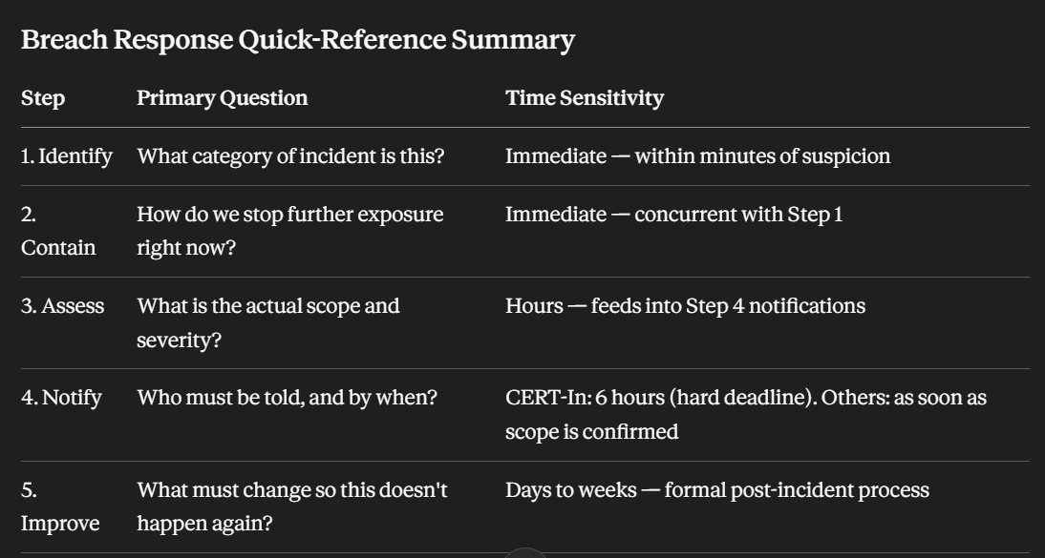

Part I Implementation Checklist

